Key information
- Entertainment providers (Eps) register onto the app.
  - Name
  - Business number
  - Email
  - Description
- System verifies that EPs are valid based on querying a University-owned API.
  - Query if an EP is legitimate.
  - Disallow illegitimate EPs.
- EPs can organise events.
  - Type - mandatory
  - Title – mandatory
  - Ticketed or non-ticketed – mandatory
Assumed that the rest are optional (ambiguity)
  - Indoors or outdoors
  - Capacity
  - Smoking or non-smoking
- EPs can request to see all the performances for a certain date.
- They can edit performances with no bookings yet
Ambiguity is whether or not EPs can edit performances with bookings.
- Students are pre-registered with their university email and password.
  - Can request a list of events for certain date and view events in detail.
  - They can book a performance, choosing the number of tickets they would like to book. (Doesn’t specify whether EPs can limit tickets per person – ambiguity)
- Payments are handled by an external provider.
  - Unique booking number is issued after successful payment and a record is created with the student’s name and contact info (email/phone).
  - Details can be used to advertise similar events.
  - Bookings can be cancelled at least 24 hrs in advance.
  - EPs can cancel events at any time and then payment is refunded if booking was made on our system.
  - External payment system notifies all parties involved of payments and reimbursements
  - Ticket payments are transferred to the university’s bank accounts.
  - University’s finance team transfers funds to EPs.
- University admin staff are pre-registed and can log in.
  - Staff can request list of performances and see details of them just like students.
  - Staff can decide if the university sponsors a ticketed performance and decide how much money a ticket will be discounted by (up to total ticket price).
- University’s own API where you put the name of the business and it is stated whether it’s approved or not.
- Preference system for students (ambiguity on how to implement it). Events are prioritised based on preferences.
- Ways to add ratings, comments and display an average rating
- Ambiguity on whether if there are multiple performances, there must be a way to rate individual events.
- Not allow bookings for non-ticketed events
- Ambiguity on whether you can see past events and/or how long ago of events you can see.
Ambiguities (ask during interview)
- Is indoors/outdoors disclosure mandatory (as in a specification in an event invitation)?
- Is smoking/non-smoking disclosure mandatory?
- Is Capacity disclosure required
- Can EPs edit performances/events that already have bookings?
- Can there be a maximum number of ticket purchases per person?
- How exactly to implement the preference systems. Any specific factors?
- How to implement ratings? The event as a whole or individual performances?
- How far in the past are we able to see previous events? Can we see past events?
- Can a university sponsor an event that already had some tickets purchased?
- If a university can sponsor non-ticketed events, would that include the cost of running the event, since ticket prices cannot be sponsored for those type of events?
- Does the business name have to correspond to the business number in the API?
- Do we have to specifically provide an interface for the university to transfer funds to the EP or will they do it separately in their own time? Do we have to worry about it in our implementation?
- Do we need to provide a way for students to delete/edit reviews?
- If students cancel bookings themselves, what are the requirements for getting a refund? At the moment it only specifies a refund issued if the EP cancels it.
- Should admins have the ability to cancel individual students’ bookings.

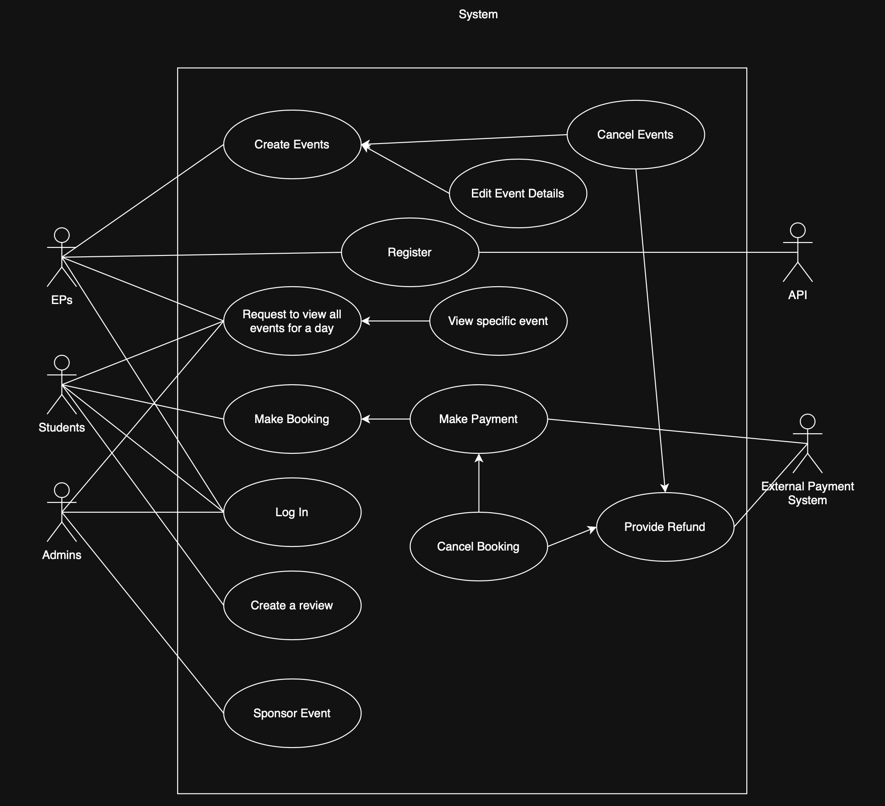
UML diagram
Stakeholders:
- Students
- Admin
- Entertainment providers
- External payment providers
- University finance team (could fall under “Admin” but too generalised)
Use Case Descriptions:
- Use case name: Register
Primary actor: Entertainment Provider (EPs)
Supporting actors: n/a
Summary: EPs must register to be able to publish event invites and interact with bookings.
Precondition: Must be in the University-approved list of providers
Trigger: Clicking register on the sign up website and agreeing to terms of account.
Guarantee: Register an account for the EP.
Main Success Scenario: Enter details (name, company registration details), read and agree to terms, wait for university to approve company and account is created.
Extensions: n/a
Notes: n/a
- Use case name: Create event (EP)
Primary actor: Entertainment Provider
Supporting actors: None
Summary: Event providers must be able to create events and register the details of that event.
Precondition: The event provider is registered and logged in
Trigger: The event provider selects an option to create and event
Guarantee: Register an event on the system that students can see
Main Success Scenario: Once logged in, the EP selects an option to create and event, they then enter the details for that event
Extensions: If the user is not logged in as an event provider, don’t allow them to select the option for create event.
Notes: non-functional requirement: the system should not allow a user to create and event if not logged in as a registered event provider
- Use case name: Edit event details
Primary actor: Entertainment provider
Supporting actors: n/a
Summary: The EP must be able to edit an event to correct any errors or update information if circumstances change.
Precondition: No bookings have been made yet for that specific event.
Trigger: Clicking confirm on the edit event GUI
Guarantee: Update the event details for when new people see the event listing or refresh the event page
Main Success Scenario:
Extensions: If bookings have already been made for an event, the entertainment provider will be unable to access the edit event GUI and be notified that the event can no longer be updated.
Notes: There must be no bookings registered for that event for it to be edited.
- Use case name: Cancel event
Primary actor: Entertainment provider
Supporting actors: n/a
Summary: EPs can cancel events that are scheduled
Precondition: n/a
Trigger: EPs confirming to cancel the event via mouse click.
Guarantee: Inform all ticket-holders that an event has been cancelled (if ticketed). The event will be unlisted.
Main Success Scenario: Entertainment provider selects their event, clicks on cancel event and confirms a cancellation. The refund issue use case should be invoked.
Extensions:
Notes:
- Use case name: Refund issued [may be too specific of a use case. Double check if it’s necessary]
Primary actor: Payment provider
Supporting actors: students
Summary: The payment system must be invoked to provide a refund to students who have bought a ticket for a performance that an event provider has cancelled.
Precondition: An event provider has cancelled a paid, ticketed performance
Trigger: An event provider cancels a paid, ticketed performance
Guarantee: The system must ensure students who bought a ticket for the performance that was cancelled are issued a refund.
Main Success Scenario: The payment provider API is told that a paid, ticketed performance has been cancelled; the payment provider then provides a refund for students who had bought a ticket for that performance
Extensions: The performance was a free event: no refund issued to students
Notes: non-functional: the system ensure the refund goes to the correct user.
NEED TO DOUBLE CHECK THIS IS NON-FUNCTIONAL
- Use case name: Search events for a specific day
Primary actor: Students, Admins
Supporting actors:
Summary: students must be able to query the system for a list of events for a given date. The system must return the correct list
Precondition: the user is logged in as a regi
Trigger:
Guarantee:
Main Success Scenario:
Extensions:
Notes:
- Use case name: View specific event
Primary actor: Students
Supporting actors: Admins / EPs
Summary:
Precondition:
Trigger:
Guarantee:
Main Success Scenario:
Extensions:
Notes:
- Use case name: Make booking
Primary actor: Students
Supporting actors:
Summary:
Precondition:
Trigger:
Guarantee:
Main Success Scenario:
Extensions:
Notes:
- Use case name: Checkout [may be too specific of a use case. Double check if it’s necessary]
Primary actor: Students
Supporting actors: Payment provider
Summary:
Precondition:
Trigger:
Guarantee:
Main Success Scenario:
Extensions:
Notes:
- Use case name: Cancel booking
Primary actor: Students
Supporting actors:
Summary:
Precondition: Event is at least 24 hours away from starting
Trigger:
Guarantee:
Main Success Scenario:
Extensions:
Notes:
- Use case name: Create reviews after the event
Primary actor: Student
Supporting actors:
Summary:
Precondition: The event must be finished (current time > scheduled end time)
Trigger:
Guarantee:
Main Success Scenario:
Extensions:
Notes:
- Use case name: Cancel event
Primary actor: Entertainment provider
Supporting actors: n/a
Summary:
Precondition:
Trigger:
Guarantee:
Main Success Scenario:
Extensions:
Notes:
- Use case name: Sponsor event
Primary actor: Admin
Supporting actors:
Summary:
Precondition:
Trigger:
Guarantee:
Main Success Scenario:
Extensions:
Notes:
- Use case name: Login [may be too specific of a use case. Double check if it’s necessary]
Primary actor: Student
Supporting actors: Entertainment provider, Admin
Summary:
Precondition:
Trigger:
Guarantee:
Main Success Scenario:
Extensions:
Notes:

[Paste high quality screenshot of the UML diagram here]

